Q1. TOKENISATION AND WORD STATISTICS
1. INTRODUCTION
Tokenisation is the process of dividing text into smaller units called tokens. These tokens may include words, numbers, punctuation marks and symbols. It is an important first step in Natural Language Processing. Word statistics help identify the frequency and distribution of words in a given document.
2. TOKENISATION CRITERIA
The following criteria are used for tokenisation:
- Whitespace: Spaces are used to separate words.
- Punctuation: Symbols such as commas, full stops and exclamation marks are identified.
- Contractions: Words such as "can't" and "won't" are handled consistently.
- Hyphenated Words: Words such as "value-for-money" are treated according to the selected tokenisation rule.
- Numbers: Numbers such as "Rs.499" and "4G/5G" are identified.
- Emoticons: Symbols such as ":(" are retained as tokens.
- Repeated Words: Repeated words such as "ok ok" are counted separately.
3. SAMPLE CUSTOMER REVIEWS
The five sample reviews are:
- Can't connect!! Net speed 4G/5G isn't consistent :(
- Won't recharge via e-wallet.
- Rs.499 plan is value-for-money.
- It is the-best-network, no? ok ok.
- Super service da, semma speed.
4. AMBIGUOUS STRING
The string "4G/5G" is ambiguous because it contains two network generations separated by a slash. It can be treated as one token or divided into two tokens.
For customer reviews, treating it as one token preserves its original meaning.
5. WORD STATISTICS
The following measurements are used:
- Total Tokens (N): Total number of tokens in the corpus.
- Vocabulary Size (V): Total number of unique tokens.
- Type-Token Ratio (TTR): Ratio of unique tokens to total tokens.
- Hapax Legomena: Words that appear only once in the corpus.
- Top 10 Words: Ten words with the highest frequency.
Formula:
TTR = Vocabulary Size / Total Tokens
6. ZIPF'S LAW
Zipf's Law explains the relationship between the frequency of a word and its rank.
It states that a small number of words occur very frequently, while most words occur less frequently.
A log-log graph is used to represent word rank against word frequency. The slope helps understand the distribution of words in the corpus.
7. RESULT
Tokenisation divides customer reviews into meaningful units. Word statistics and Zipf's Law help analyse the frequency, vocabulary size and distribution of words in a text corpus.
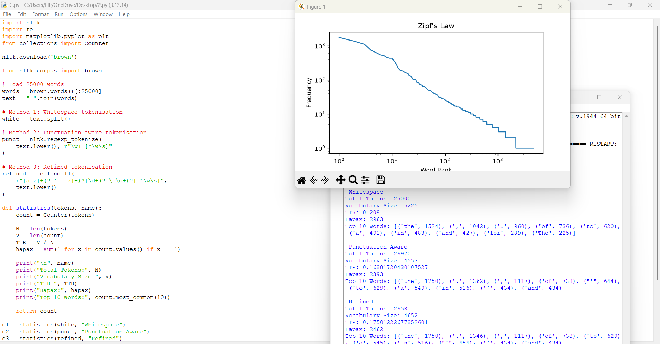
Q2. UNSMOOTHED N-GRAMS AND SPARSITY
1. INTRODUCTION
An N-gram is a sequence of N consecutive words in a sentence. N-gram models are used in NLP to predict the next word based on previously occurring words.
2. TYPES OF N-GRAMS
- Unigram: A sequence containing one word.
- Bigram: A sequence containing two consecutive words.
- Trigram: A sequence containing three consecutive words.
- Four-gram: A sequence containing four consecutive words.
Example sentence: "The network is fast."
- Unigrams: The, network, is, fast.
- Bigrams: The network, network is, is fast.
- Trigrams: The network is, network is fast.
- Four-gram: The network is fast.
3. CHAIN RULE OF PROBABILITY
The chain rule represents the probability of a complete sentence using conditional probabilities.
Formula:
P(w₁, w₂, ..., wₙ) = P(w₁) × P(w₂|w₁) × P(w₃|w₁,w₂) × ... × P(wₙ|w₁,...,wₙ₋₁)
It considers the previous words while calculating the probability of the next word.
4. N-GRAM APPROXIMATION
N-gram models simplify the chain rule by considering only a limited number of previous words.
Unigram Model: Considers individual word probabilities.
Bigram Model: Predicts a word using the immediately preceding word.
Trigram Model: Predicts a word using the previous two words.
Higher-order N-grams provide more context but require more training data.
5. MAXIMUM LIKELIHOOD ESTIMATION
Maximum Likelihood Estimation (MLE) calculates the probability of an N-gram using its frequency in the training corpus.
Formula:
P(wᵢ | previous words) = Count of the complete N-gram / Count of the previous words
It estimates probabilities based on the observed frequency of word combinations.
6. N-GRAM SPARSITY
N-gram sparsity occurs when many possible word combinations do not appear in the training dataset. As the value of N increases, the number of possible word combinations also increases.
N-gram | Description | Expected Sparsity
Unigram | Single words | Low
Bigram | Two words | Moderate
Trigram | Three words | High
Four-gram | Four words | Very High
7. DATASET DESIGN
Three datasets are considered:
- In-Domain Helpdesk Dataset: Contains customer complaints, network issues, recharge problems and service-related sentences.
- Out-of-Domain News Dataset: Contains news articles and general information.
- Edge-Case Dataset: Contains short sentences, repeated words, punctuation, numbers and unusual word combinations.
The datasets are divided into 80% training data and 20% testing data using a fixed random seed.
8. EXPERIMENTAL OBSERVATIONS
The experiment records:
- Number of distinct N-grams.
- Percentage of unseen N-grams.
- Number of zero-probability sentences.
- Sample sentences generated by the model.
- Differences between training and testing data.
Unigram models generally have fewer unseen combinations, while higher-order models are more likely to face sparsity.
9. MODEL SELECTION
For a 50 MB dataset without smoothing, a bigram model can be considered a practical starting point because it provides context without the large storage requirements of higher-order models.
10. RESULT
N-gram models are useful for predicting word sequences. However, higher-order models face sparsity because many word combinations may not occur in the training data. Bigram models provide a balance between context and data requirements.
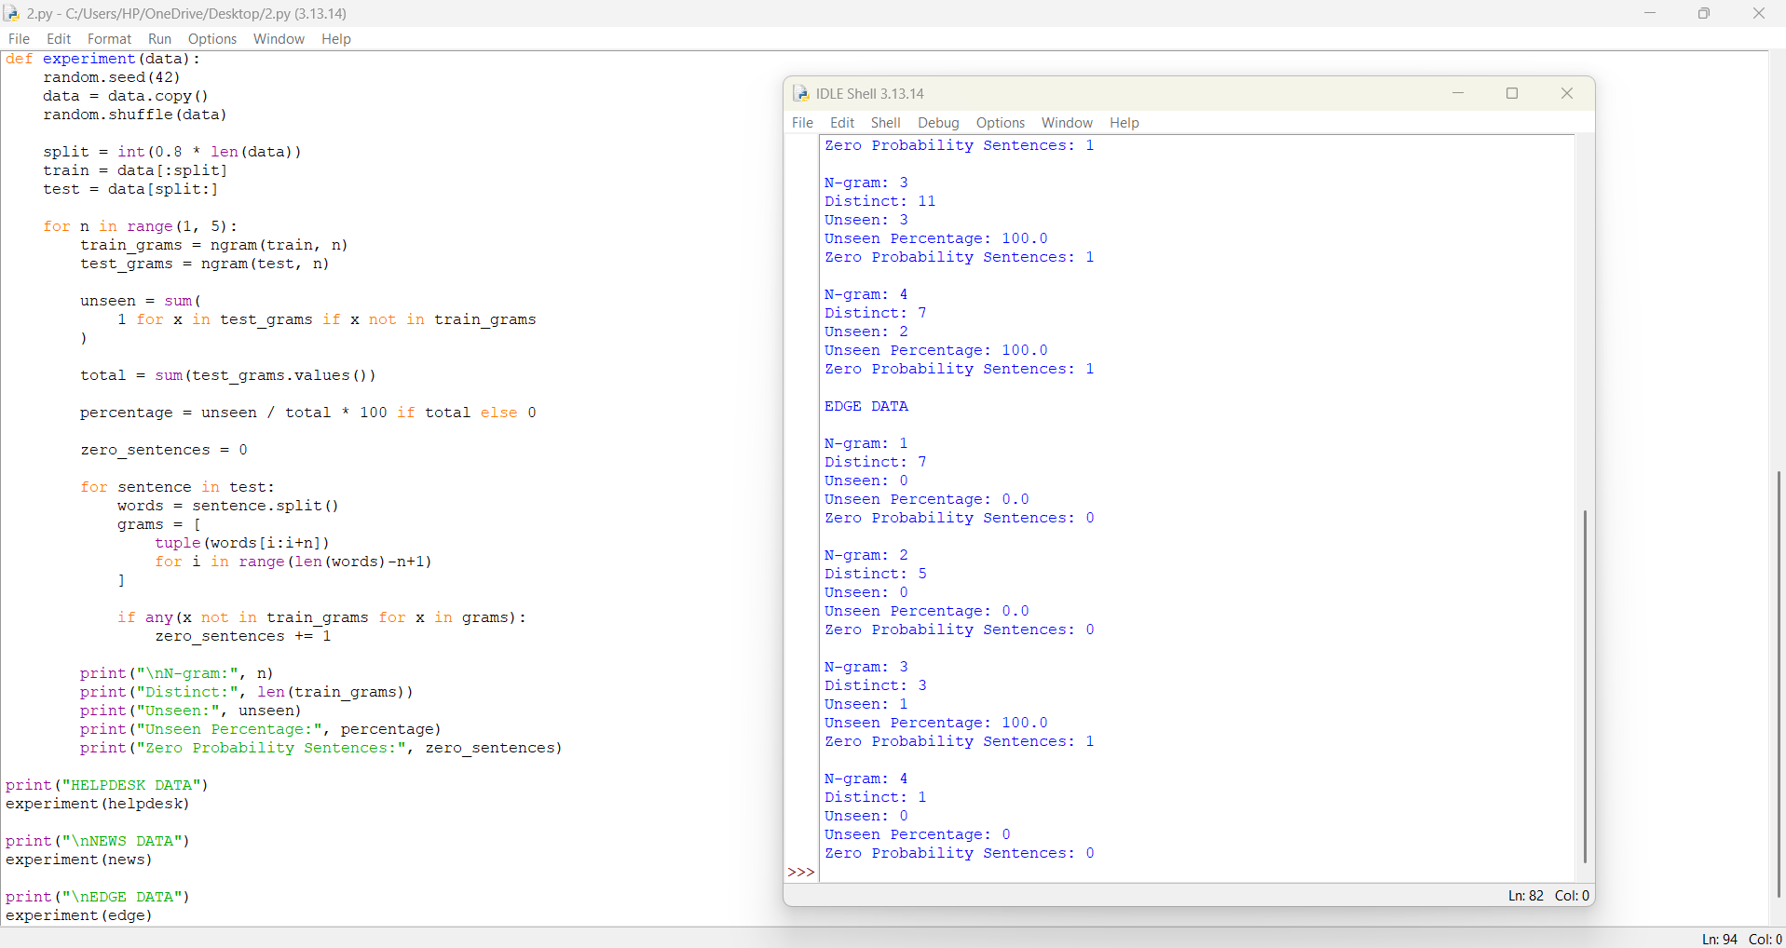
Q3. SMOOTHING TECHNIQUES: ADD-ONE, BACKOFF AND DELETED INTERPOLATION
1. INTRODUCTION
Smoothing is a technique used in language models to handle unseen word combinations. In an unsmoothed model, unseen N-grams receive zero probability. Smoothing techniques assign probabilities to unseen combinations and improve language model performance.
2. ADD-ONE SMOOTHING
Add-One smoothing is also known as Laplace smoothing. It adds 1 to every N-gram count to avoid zero probabilities.
Formula:
P(wᵢ | wᵢ₋₁) = [C(wᵢ₋₁,wᵢ) + 1] / [C(wᵢ₋₁) + V]
Where:
- C(wᵢ₋₁,wᵢ) = Bigram count.
- C(wᵢ₋₁) = Previous word count.
- V = Vocabulary size.
It ensures that unseen bigrams receive a non-zero probability.
3. ADD-k SMOOTHING
Add-k smoothing adds a small value k instead of 1.
Formula:
P(wᵢ | wᵢ₋₁) = [C(wᵢ₋₁,wᵢ) + k] / [C(wᵢ₋₁) + kV]
When k = 1, it becomes Add-One smoothing.
Add-k smoothing provides better control over the probability assigned to unseen combinations.
4. BACKOFF WITH DISCOUNTING
Backoff uses a lower-order N-gram model when a higher-order N-gram is unavailable. Discounting slightly reduces the probability of observed N-grams to reserve probability for unseen combinations.
For a seen bigram:
P(wᵢ | wᵢ₋₁) = [C(wᵢ₋₁,wᵢ) − D] / C(wᵢ₋₁)
For an unseen bigram, the model uses a lower-order probability with a backoff weight.
Where:
- D = Discount value.
- α = Backoff weight.
- P(wᵢ) = Unigram probability.
Backoff helps the model predict unseen word combinations using lower-order information.
5. DELETED INTERPOLATION
Deleted interpolation combines different N-gram models using weights.
For a unigram and bigram model:
Formula:
P(wᵢ | wᵢ₋₁) = λ₁P(wᵢ) + λ₂P(wᵢ | wᵢ₋₁)
Where:
- λ₁ = Unigram weight.
- λ₂ = Bigram weight.
- λ₁ + λ₂ = 1.
The weights are estimated using held-out or deleted observations.
It combines different probability estimates to produce more reliable predictions.
6. PERPLEXITY COMPARISON
Perplexity measures how well a language model predicts a test dataset.
Training Data | Expected Observation
10% | Higher perplexity due to limited training data.
50% | Perplexity is expected to decrease as more patterns are learned.
100% | Lower perplexity may be achieved when additional data improves coverage.
Actual perplexity values must be calculated using the selected training and testing datasets.
7. PROBABILITY MASS IN ADD-ONE SMOOTHING
Add-One smoothing distributes probability among observed and unseen bigrams.
When the vocabulary size is large, many possible bigrams may not occur in the training data. Therefore, Add-One smoothing may assign excessive probability to unseen combinations. This can reduce the probability assigned to frequently observed combinations.
8. EXPERIMENTAL OBSERVATIONS
The experiment should include:
- Held-out perplexity for each smoothing method.
- Unseen probability mass.
- Learned interpolation weights.
- Reconstituted counts for seen bigrams.
- Conditional probability sums for at least 10 histories.
- Comparison of matching-domain, domain-shift and edge-case datasets.
9. RESULT
Add-One, Add-k, backoff and deleted interpolation help language models handle unseen word combinations. Their performance can be compared using held-out perplexity and probability distribution measurements.
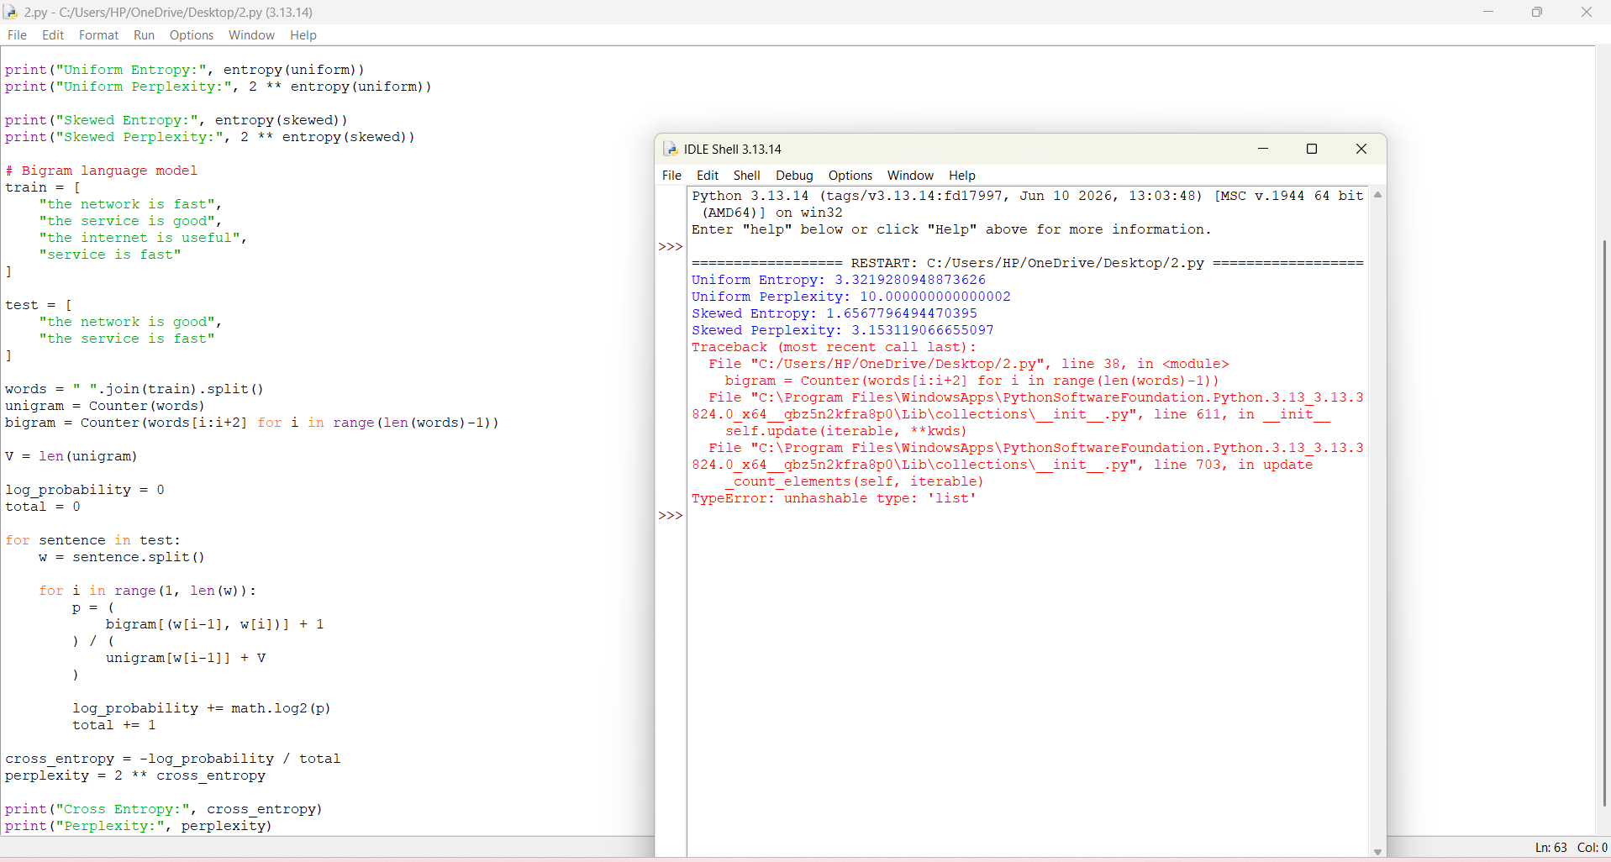
Q4. ENTROPY AND PERPLEXITY
1. INTRODUCTION
Entropy and perplexity are important measurements used to evaluate language models. Entropy measures the uncertainty in predicting the next word. Perplexity measures how well a language model predicts a sequence of words. Lower perplexity generally indicates better prediction performance when models are evaluated on the same test data.
2. ENTROPY
Entropy measures the average uncertainty associated with a probability distribution.
Formula:
H(X) = −Σ P(x) log₂ P(x)
Where:
- P(x) = Probability of an event.
- log₂ = Logarithm with base 2.
Higher entropy indicates greater uncertainty, while lower entropy indicates less uncertainty.
3. CROSS-ENTROPY
Cross-entropy measures the average number of bits required by a model to predict words in a test sequence.
Formula:
H = −(1/N) Σ log₂ P(wᵢ | context)
Where:
- N = Number of test words.
- P(wᵢ | context) = Predicted probability of each word.
4. PERPLEXITY
Perplexity is calculated from cross-entropy.
Formula:
PP = 2ᴴ
Where H represents cross-entropy per word.
Lower perplexity indicates that the model is less uncertain about the next word.
5. TOY PROBABILITY DISTRIBUTIONS
Uniform Distribution:
Consider 10 possible outcomes, each having an equal probability.
P(x) = 1/10
Entropy:
H = −10 × (0.1 × log₂ 0.1)
H ≈ 3.322 bits
Perplexity:
PP = 2³·³²² ≈ 10
Skewed Distribution:
A skewed distribution has one or more outcomes with higher probabilities and other outcomes with lower probabilities. Its entropy is lower than that of a uniform distribution with the same number of outcomes.Therefore, its perplexity is also lower.
6. COMPARISON OF N-GRAM MODELS
The following models are compared:
- Unigram Model.
- Bigram Model.
- Trigram Model.
The best smoothing technique selected in Q3 is applied to these models.
The models are evaluated using:
- In-domain helpdesk text.
- Out-of-domain news text.
- Edge-case text.
7. UNKNOWN WORDS AND VOCABULARY
Unknown words are words that do not appear in the training vocabulary. A restricted vocabulary may increase the number of unknown words in the test dataset. The UNK token is used to represent unknown words. It helps the model handle words that were not present during training.
8. EXPERIMENTAL OBSERVATIONS
The experiment records:
- Entropy values.
- Perplexity values.
- Number of unknown words.
- Differences between unigram, bigram and trigram models.
- Effect of restricted vocabulary and UNK handling.
Out-of-domain text may have higher perplexity because its vocabulary and word patterns differ from the training data.
9. RESULT
Entropy measures uncertainty, while perplexity evaluates language model prediction performance. N-gram models can be compared using cross-entropy and perplexity on different datasets. UNK handling helps the model process words outside the training vocabulary.

Q5. WORD CLASSES AND TAGSET DESIGN
1. INTRODUCTION
Word classes are groups of words that perform similar grammatical functions in a sentence. They are also called Parts of Speech (POS).Examples include nouns, verbs, adjectives, adverbs, pronouns and prepositions. POS tagging assigns a grammatical label to each word in a sentence.
2. OPEN-CLASS WORDS
Open-class words are categories that can accept new words over time.
Examples:
- Nouns: Network, phone, customer.
- Verbs: Connect, recharge, download.
- Adjectives: Fast, slow, reliable.
- Adverbs: Quickly, clearly, properly.
These categories frequently receive new words from technology, culture and everyday communication.
3. CLOSED-CLASS WORDS
Closed-class words are categories that contain a relatively fixed set of words.
Examples:
- Pronouns: He, she, they, it.
- Prepositions: In, on, at, under.
- Conjunctions: And, but, or.
- Determiners: A, an, the.
- Auxiliary Verbs: Is, am, are, was.
4. DISTRIBUTIONAL EVIDENCE
Distributional evidence identifies word classes based on how words appear in sentences.
Examples:
- Nouns can occur after determiners, such as "the network".
- Verbs can occur after subjects, such as "customers complain".
- Adjectives can occur before nouns, such as "fast network".
- Adverbs can modify verbs, such as "works properly".
Inflectional changes also help identify word classes.
Examples:
- Nouns: Customer, customers.
- Verbs: Connect, connects, connected.
- Adjectives: Fast, faster, fastest.
5. TAGSET DESIGN
A tagset is a collection of labels used to identify grammatical categories.
1. Universal POS Tagset
It contains general labels such as NOUN, VERB, ADJ, ADV and PRON.
2. Penn Treebank Tagset
It provides more detailed grammatical labels such as NN, NNS, VB, VBD and JJ.
3. Custom Fine-Grained Tagset
It uses specific labels based on the application.
Examples:
- PRODUCT_NAME
- COMPLAINT_VERB
- SERVICE_ADJECTIVE
- CUSTOMER_NOUN
6. TAGSET COMPARISON
Tagset | Description | Advantage
Universal POS | General word categories | Simple to understand
Penn Treebank | Detailed grammatical categories | Provides more grammatical information
Custom Tagset | Application-specific categories | Useful for product and complaint extraction
A universal tagset is suitable for general POS tagging. A custom tagset may be more useful for extracting product names and complaint verbs.
7. ANNOTATION PROCESS
A dataset containing at least 100 sentences is selected for POS annotation.
Steps:
- Collect sentences from the selected corpus.
- Identify each word in the sentence.
- Assign an appropriate POS tag.
- Re-annotate the data independently or ask another person to annotate it.
- Compare the two sets of annotations.
- Calculate agreement using Cohen's Kappa.
8. COHEN'S KAPPA
Cohen's Kappa measures the agreement between two annotators.
Formula:
κ = (Pₒ − Pₑ) / (1 − Pₑ)
Where:
- Pₒ = Observed agreement.
- Pₑ = Expected agreement by chance.
A higher Kappa value indicates stronger agreement between annotators.
9. EXPERIMENTAL MEASUREMENTS
The following measurements are recorded:
- Cohen's Kappa score.
- Percentage of ambiguous word types.
- Average number of tags per word type.
- Top five confused POS tag pairs.
Measurement | Result
Total annotated sentences | 100 or more
Cohen's Kappa | Calculated value
Ambiguous word types | Calculated percentage
Average tags per word type | Calculated value
Top five confused pairs | Observed pairs
10. APPLICATION IN CUSTOMER SUPPORT
For extracting product names and complaint verbs, a custom tagset can provide useful application-specific information.
Example sentence:
"Customers report slow internet service."
Word | Tag
Customers | CUSTOMER_NOUN
report | COMPLAINT_VERB
slow | SERVICE_ADJECTIVE
internet | PRODUCT_NOUN
service | SERVICE_NOUN
11. RESULT
Word classes help identify grammatical roles in sentences. POS tagging assigns appropriate labels to words. Universal, Penn Treebank and custom tagsets provide different levels of grammatical detail. A custom tagset can be useful for extracting product names and complaint-related information.
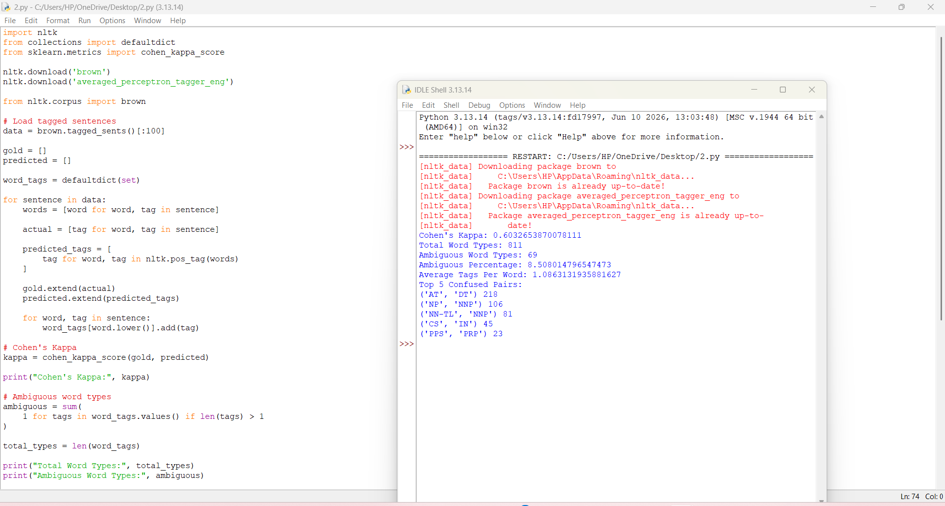
Q6. RULE-BASED, STOCHASTIC AND TRANSFORMATION-BASED TAGGING
1. INTRODUCTION
POS tagging assigns grammatical categories to words in a sentence.
Different tagging approaches are used to identify the correct tag based on word information and surrounding context.
The three approaches considered are:
- Rule-Based Tagging.
- Stochastic Tagging.
- Transformation-Based Tagging.
2. RULE-BASED TAGGING
Rule-based tagging uses predefined grammatical rules to assign POS tags.
Examples:
- A word ending in "ing" may be a verb.
- A word ending in "ly" may be an adverb.
- A word after "the" may be a noun.
- A word after "is" may be an adjective or verb.
- A word ending in "ed" may be a past-tense verb.
- A word before a noun may be an adjective.
- A word after a subject may be a verb.
- Words such as "and" and "but" are conjunctions.
- Words such as "in" and "on" are prepositions.
- Words such as "he" and "they" are pronouns.
Rule-based tagging is simple and understandable, but it may not handle every grammatical situation.
3. STOCHASTIC TAGGING
Stochastic tagging uses probabilities to identify the most suitable POS tag.
A Hidden Markov Model (HMM) is a commonly used stochastic tagging method.
It uses two important probabilities:
- Transition Probability: Probability of one POS tag following another POS tag.
- Emission Probability: Probability of a word appearing with a particular POS tag.
The Viterbi algorithm is used to identify the most probable sequence of POS tags.
4. TRANSFORMATION-BASED TAGGING
Transformation-based tagging combines an initial tagging process with correction rules. It first assigns basic tags and then applies transformation rules to correct errors.
The Brill tagger is an example of transformation-based tagging.
Steps:
- Assign initial POS tags.
- Compare predicted tags with correct tags.
- Identify tagging errors.
- Generate transformation rules.
- Select useful rules.
- Apply the rules to improve tagging accuracy.
5. COMPARISON OF TAGGING METHODS
Method | Working Principle | Advantage
Rule-Based | Uses predefined rules | Easy to understand
Stochastic | Uses statistical probabilities | Handles context
Transformation-Based | Corrects initial tags using rules | Improves initial tagging
6. MOST-FREQUENT-TAG BASELINE
The most-frequent-tag baseline assigns the most common tag observed for each word in the training corpus.
It provides a simple reference point for comparing more advanced tagging methods.
7. UNKNOWN-WORD HANDLING
Unknown words are words that are not present in the training vocabulary.
They can be handled using:
- Suffix information.
- Prefix information.
- Capitalisation.
- Word shape.
- Default POS tags.
These features help the tagger make predictions for words that were not seen during training.
8. EXPERIMENTAL EVALUATION
The following measurements are recorded:
- Overall tagging accuracy.
- Accuracy on known words.
- Accuracy on unknown words.
- Accuracy on out-of-domain data.
- Confusion matrix.
- Number of transformation rules.
- Viterbi transition probabilities.
- Accuracy improvement after transformation.
The models should be tested using fixed training and testing splits with the same random seed.
9. TRAINING DATA COMPARISON
Training Data | Expected Observation
10% | Lower accuracy due to limited training examples.
50% | Improved accuracy with more training examples.
100% | Better vocabulary coverage is expected.
The actual results should be calculated using the selected tagged corpus.
10. RECOMMENDATION FOR LOW-RESOURCE DATA
For a dataset containing approximately 2,000 tagged sentences, a combination of a most-frequent-tag baseline and transformation-based tagging can be considered.
A rule-based component can also help handle unknown words.
The final method should be selected based on measured accuracy, training requirements and performance on unknown words.
11. RESULT
Rule-based, stochastic and transformation-based tagging approaches provide different methods for assigning POS tags. Rule-based tagging uses grammatical rules, stochastic tagging uses probabilities, and transformation-based tagging corrects initial tagging errors. Their performance can be compared using tagging accuracy and confusion matrices.
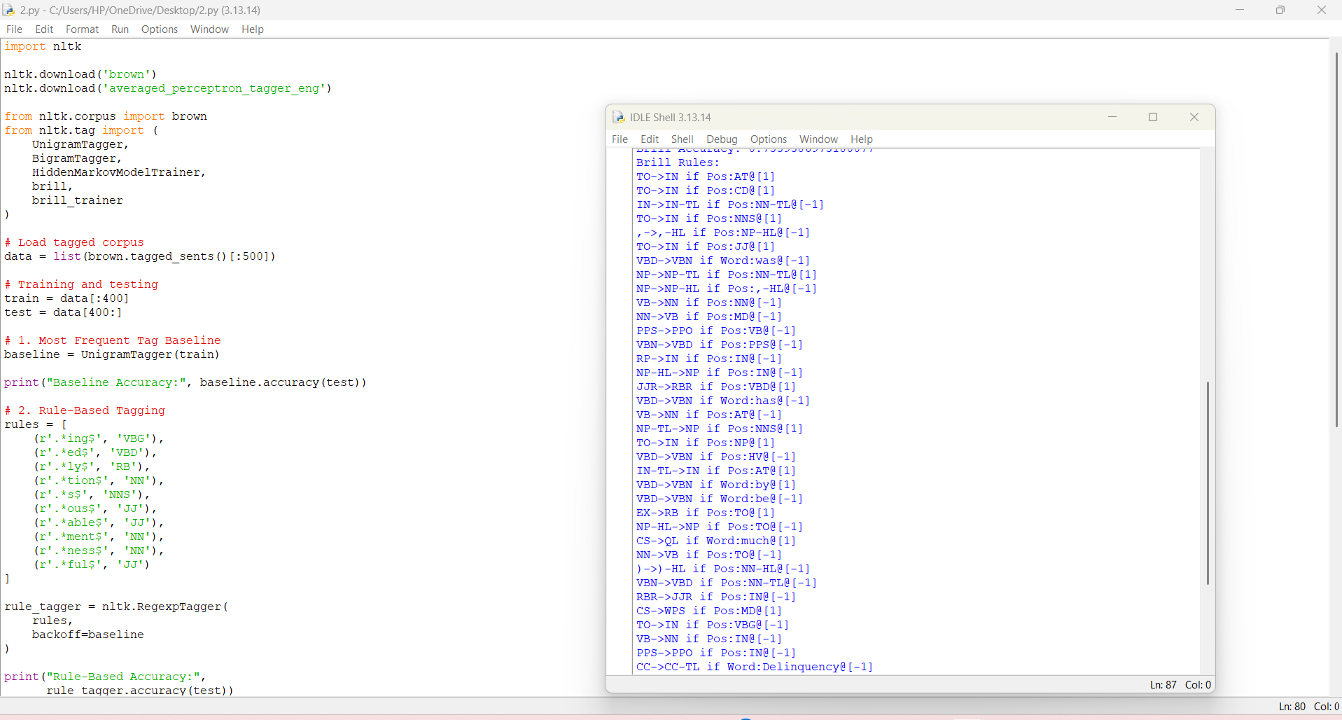
Q7. DAY-4 DESIGN CHALLENGE: DIAGNOSE, REDESIGN AND VALIDATE
1. INTRODUCTION
The design challenge focuses on identifying a limitation in an existing NLP system and developing an improved solution. The selected limitation is the handling of unknown words in a POS tagging system. Unknown words create difficulties because the tagger has not seen them during training.
2. A. DIAGNOSE THE LIMITATION
The major limitation identified is poor tagging performance on unknown words.
Reasons:
- Unknown words are not available in the training vocabulary.
- The model may not identify new technical terms correctly.
- Similar words may have different grammatical roles.
- Out-of-domain text may contain unfamiliar vocabulary.
- A simple baseline may assign incorrect tags to new words.
This limitation affects the accuracy of POS tagging, especially in customer-support and technical documents.
3. B. MEASURABLE OBJECTIVE
The main objective is to improve the tagging accuracy of unknown words without replacing the existing model.
The redesigned system aims to:
- Identify unknown words.
- Analyse their prefixes and suffixes.
- Use surrounding word information.
- Apply suitable grammatical rules.
- Compare the improved model with the original model.
The improvement is measured using unknown-word accuracy and overall tagging accuracy.
4. C. REDESIGN STRATEGY
The proposed solution is a Feature-Based Unknown Word Handling System.
It combines word information, suffix rules and surrounding context.
The system uses the following features:
1. Suffix Analysis
Identifies word endings such as "ing", "ed", "ly" and "tion".
2. Prefix Analysis
Identifies prefixes such as "un", "re" and "dis".
3. Capitalisation
Uses capital letters to identify possible proper nouns.
4. Context Analysis
Checks the surrounding words to identify the grammatical role.
5. Default Tag Selection
Assigns a suitable default tag when no strong evidence is available.
5. SYSTEM WORKFLOW
The proposed system follows these steps:
- Receive the input sentence.
- Divide the sentence into tokens.
- Check whether each word is present in the training vocabulary.
- If the word is known, use the existing tagger.
- If the word is unknown, analyse its word features.
- Apply suffix, prefix and context-based rules.
- Assign the most suitable POS tag.
- Display the final tagged sentence.
7. D. EXPECTED RESULTS
The redesigned system is expected to:
- Improve unknown-word handling.
- Reduce incorrect POS assignments.
- Improve tagging performance on technical words.
- Reduce dependence on memorised vocabulary.
- Provide better results on new customer-support sentences.
The actual improvement must be measured using the same test dataset.
8. E. VALIDATION AND COMPARISON
The original and redesigned systems are tested using the same training and testing datasets.
Evaluation | Original System | Redesigned System
Overall Accuracy | Measured value | Measured value
Known Word Accuracy | Measured value | Measured value
Unknown Word Accuracy | Measured value | Measured value
Out-of-Domain Accuracy | Measured value | Measured value
Processing Time | Measured value | Measured value
The comparison helps identify whether the redesigned system improves unknown-word handling without reducing the performance of known words.
9. FINAL DISCUSSION
The redesigned system uses word features and grammatical rules to improve unknown-word tagging.
Unlike a basic tagging system, it considers suffixes, prefixes, capitalisation and surrounding context.
The approach is simple to implement and does not require a large training dataset. However, rule-based predictions may still produce errors when a word has multiple grammatical roles.
The performance should therefore be validated using actual test data.
10. RESULT
The design challenge identifies unknown-word handling as an important limitation in POS tagging. A feature-based redesign is proposed using suffix analysis, prefix analysis and context-based rules. The redesigned system can be compared with the original system using overall accuracy, known-word accuracy and unknown-word accuracy.


